Report of Mini-project On

MediGuru: Chatbot for Dengue

Submitted in partial fulfillment of the requirements of the Mini project in the Subject: AI FOR HEALTHCARE of

Semester VII, FINAL Year Computer Science and Engineering [Data Science]

by

Samarth Mane (Roll No. 30)

Janhavi Desale (Roll No. 08) Aayush Jha (Roll No. 22) Vishal Phatkare (Roll No. 47)



**University of Mumbai Vidyavardhini's College of Engineering & Technology**

**Department of Computer Science and Engineering[Data Science]**



**(A.Y. 2023-24)**

# CERTIFICATE

This is to certify that the Mini Project entitled **“MediGuru: Chatbot for Dengue”** is submitted by **Samarth Mane (Roll no. 30), Janhavi Desale (Roll No. 08), Aayush Jha (Roll No. 22), Vishal Phatkare (Roll No.47)** for the subject of AI for Healthcare in the Department of Computer Science and Engineering (Data Science) as a record of work done by him/her under our supervision and guidance.

**Guide**

**Mr. Ichhanshu Jaiswal**

# Contents

|  |  |  |
| --- | --- | --- |
| **Sr no** | **Title** | **Page No** |
| 1 | Introduction of Project | 1 |
| 2 | Importance of Project | 2 |
| 3 | Screenshot of Project | 3 |
| 4 | Conclusion | 5 |

**INTRODUCTION**

Dengue fever, a pervasive mosquito-borne viral disease, stands as a formidable global health challenge, affecting millions across more than 100 countries. Transmitted primarily by the Aedes aegypti mosquito, dengue's clinical spectrum ranges from mild flu-like symptoms to life-threatening conditions like dengue hemorrhagic fever and dengue shock syndrome. Its global impact is profound, with increasing incidence rates and grave outbreaks affecting populations in diverse regions. In response to the growing threat of dengue, MediGuru: Chatbot for Dengue Project emerges as a pioneering and comprehensive solution. This project is designed to address a pressing need: raising awareness, providing accurate information, and extending support to individuals and communities grappling with the relentless burden of dengue. Central to the MediGuru are a set of pivotal objectives, which include education and awareness dissemination, symptom assessment, provision of preventive measures, resource location for medical facilities, real-time updates on dengue outbreaks, and the integration of multi-lingual support. These multifaceted goals converge to combat the spread of dengue and, ultimately, to reduce its impact on public health. MediGuru: Chatbot for Dengue represents a watershed moment in the ongoing battle against dengue fever. By harnessing the capabilities of artificial intelligence and chatbot technology, this initiative aspires to raise awareness, provide accurate information, and support individuals and communities impacted by dengue. It stands as a testament to the global commitment to reduce the burden of this formidable disease, ultimately saving lives and improving public health on a global scale.

**1**

**IMPORTANCE OF PROJECT**

Education and Awareness: Dengue awareness is crucial in preventing the spread of the disease. The chatbot provides a platform for disseminating accurate and up-to-date information about dengue, its causes, symptoms, prevention strategies, and treatment options.

Early Detection and Treatment: The chatbot aids in the early detection of dengue cases by assisting users in assessing their symptoms and providing guidance on when to seek medical attention. Early diagnosis and access to proper medical care are critical in preventing the progression of dengue to severe, life-threatening forms.

Preventive Measures: The chatbot offers personalized recommendations for dengue prevention, including tips on mosquito control, environmental hygiene, and personal protective measures. Empowering individuals with practical advice significantly reduces the risk of dengue infection, contributing to disease prevention.

Resource Location: Users can find nearby medical facilities, clinics, and hospitals for dengue diagnosis and treatment through the chatbot. This feature ensures quick access to healthcare services and facilitates timely intervention, especially during outbreaks.

Real-time Updates: The chatbot provides real-time updates on dengue outbreaks, the latest research findings, and government health advisories. Keeping users informed about the current dengue situation in their area is essential for timely responses to outbreaks and the adoption of appropriate preventive measures.

Multi-lingual Support: By offering support in multiple languages, the chatbot ensures that a diverse and global audience can access critical information and support, regardless of their language proficiency.

Economic Impact: Dengue carries a substantial economic burden, including medical expenses, loss of productivity, and increased healthcare costs. By reducing dengue cases through awareness and prevention, the Chatbot on Dengue Project helps alleviate this financial strain on individuals, communities, and healthcare systems.

Environmental Impact: The project contributes to environmental sustainability by promoting measures to control mosquito breeding, which is essential for dengue prevention.

**2**

**SCREENSHOTS OF PROJECT**

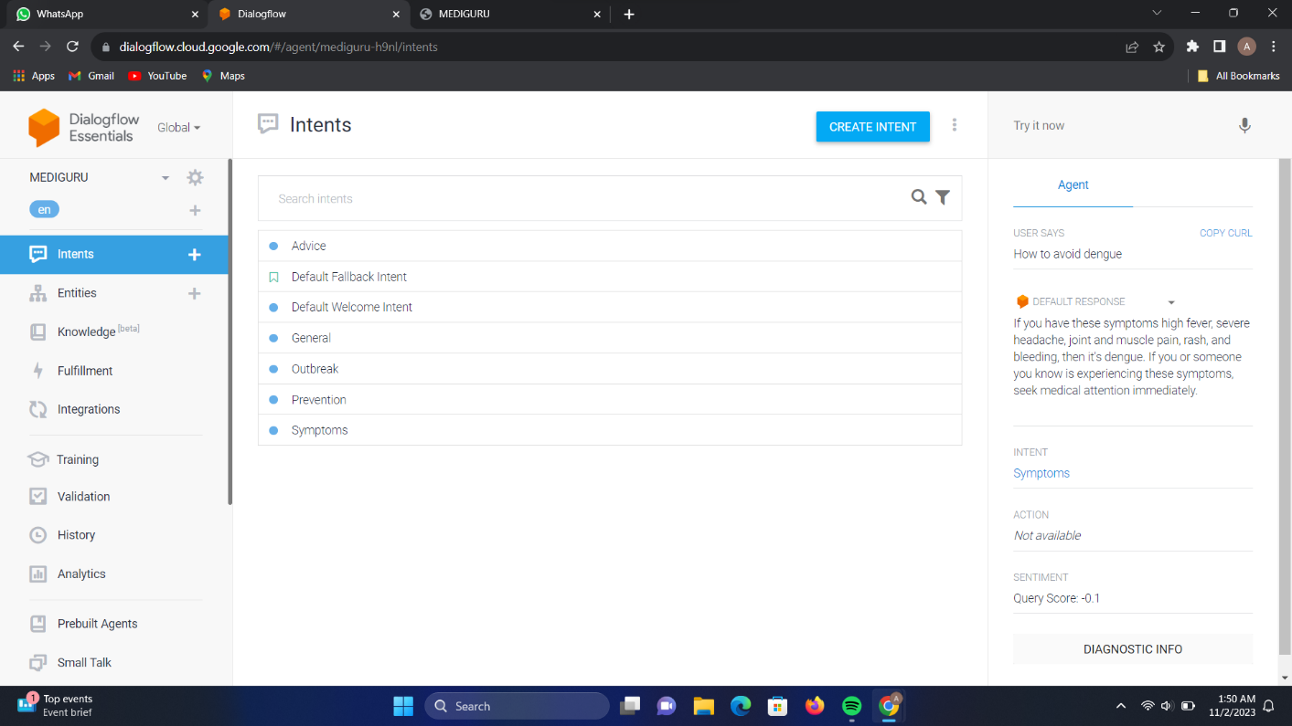1)

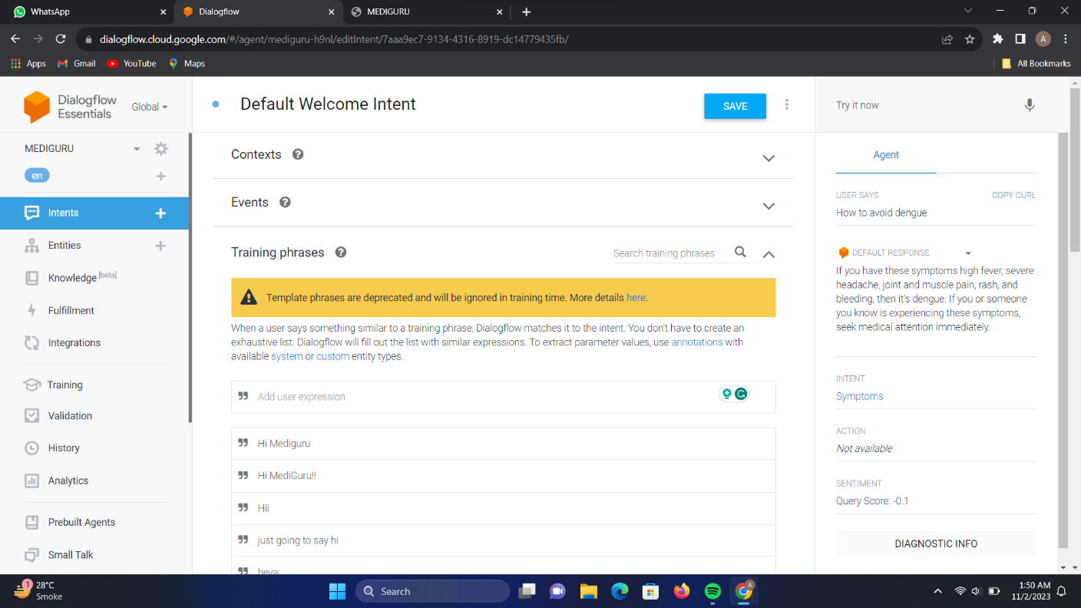2)

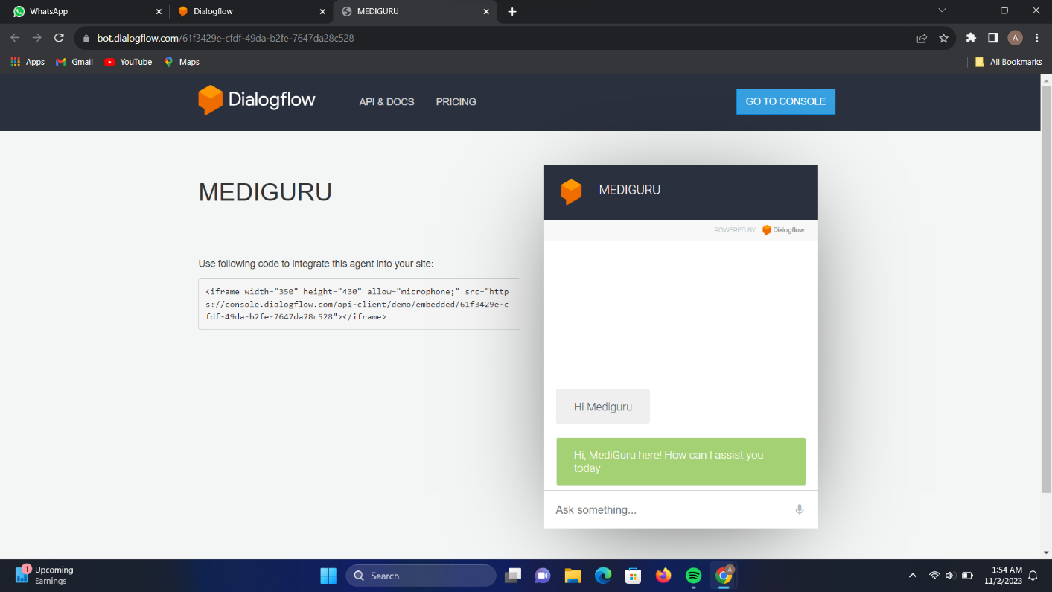3)

4)

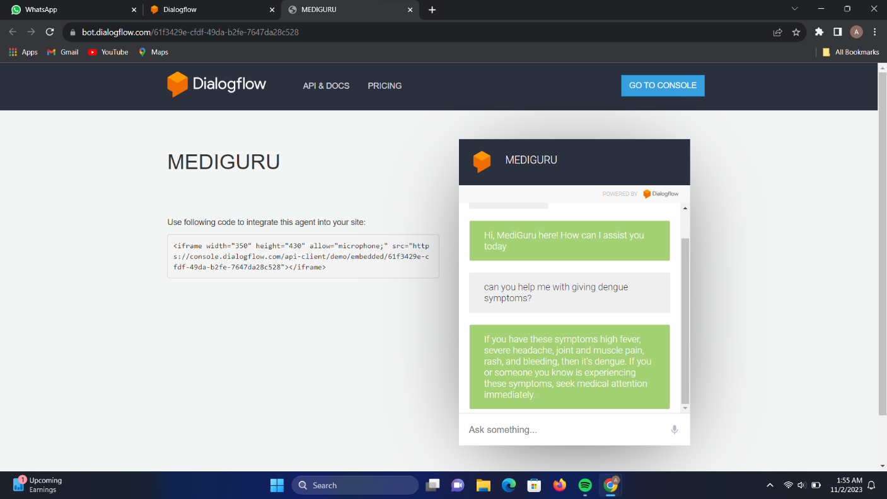

**4**

**CONCLUSION**

The MediGuru: Chatbot for Dengue, Project represents a groundbreaking tool in the realm of public health, arming individuals with vital information on Dengue's symptoms, transmission, prevention, and treatment options. With real-time updates, it keeps communities informed about the latest Dengue developments, contributing significantly to outbreak mitigation. Its multilingual accessibility ensures that a diverse population can readily access life-saving knowledge. This project not only saves lives by promoting early detection and treatment but also plays a pivotal role in reducing the economic and environmental burdens associated with Dengue. In doing so, it emerges as an indispensable asset in the global battle against this persistent and widespread health challenge, fostering a healthier and more resilient global population.

**5**